- Explain in your own words what collision detection is and why developers often use simplified shapes like rectangles or circles instead of the object’s real mesh.
Collision detection is the method of checking if two objects in a game touch or overlap so the game knows how to react, like bouncing a ball or destroying a block. Using the full shape of an object is too slow, so most games use simple shapes such as circles or rectangles (AABBs). These shapes are easy to calculate and fast, even though they are only approximations of the real sprite. The accuracy is not perfect, but it is good enough for most 2D games.
- Describe the difference between AABB–AABB and AABB–Circle collision detection. Include short pseudocode showing the main idea of how to check for overlap on both the x and y axes.
An AABB is a rectangle aligned with the x and y axes. AABB–AABB collision checks if the rectangles overlap on both the x-axis and the y-axis. If there is no gap on either axis, the two boxes are colliding.

AABB–Circle collision works differently. I find the point on the rectangle that is closest to the circle’s center. Then I check the distance between this point and the circle. If the distance is less than or equal to the radius, the circle and the box are colliding.
AABB – AABB overlap (2D):

function AABB_AABB_Overlap(A, B):
A_left = A.x
A_right = A.x + A.width
A_top = A.y
A_bottom = A.y + A.height

B_left = B.x
B_right = B.x + B.width
B_top = B.y
B_bottom = B.y + B.height

overlapX = (A_right >= B_left) and (B_right >= A_left)
overlapY = (A_bottom >= B_top) and (B_bottom >= A_top)

return overlapX and overlapY

AABB – Circle overlap (2D):

function AABB_Circle_Overlap(box, circle):
// box has center (bx, by) and half extents (hx, hy)
// circle has center (cx, cy) and radius r

dx = circle.cx - box.bx
dy = circle.cy - box.by

// clamp dx, dy to stay inside the box range
clampedX = clamp(dx, -hx, hx)
clampedY = clamp(dy, -hy, hy)

closestX = box.bx + clampedX
closestY = box.by + clampedY

distX = closestX - circle.cx
distY = closestY - circle.cy

distanceSquared = distX*distX + distY*distY

return distanceSquared <= r*r
- Draw or digitally create two diagrams:
- One that shows how AABB–AABB collision detection determines overlapping edges.
- Another that shows how to calculate the closest point on a rectangle to a circle for Circle–AABB detection
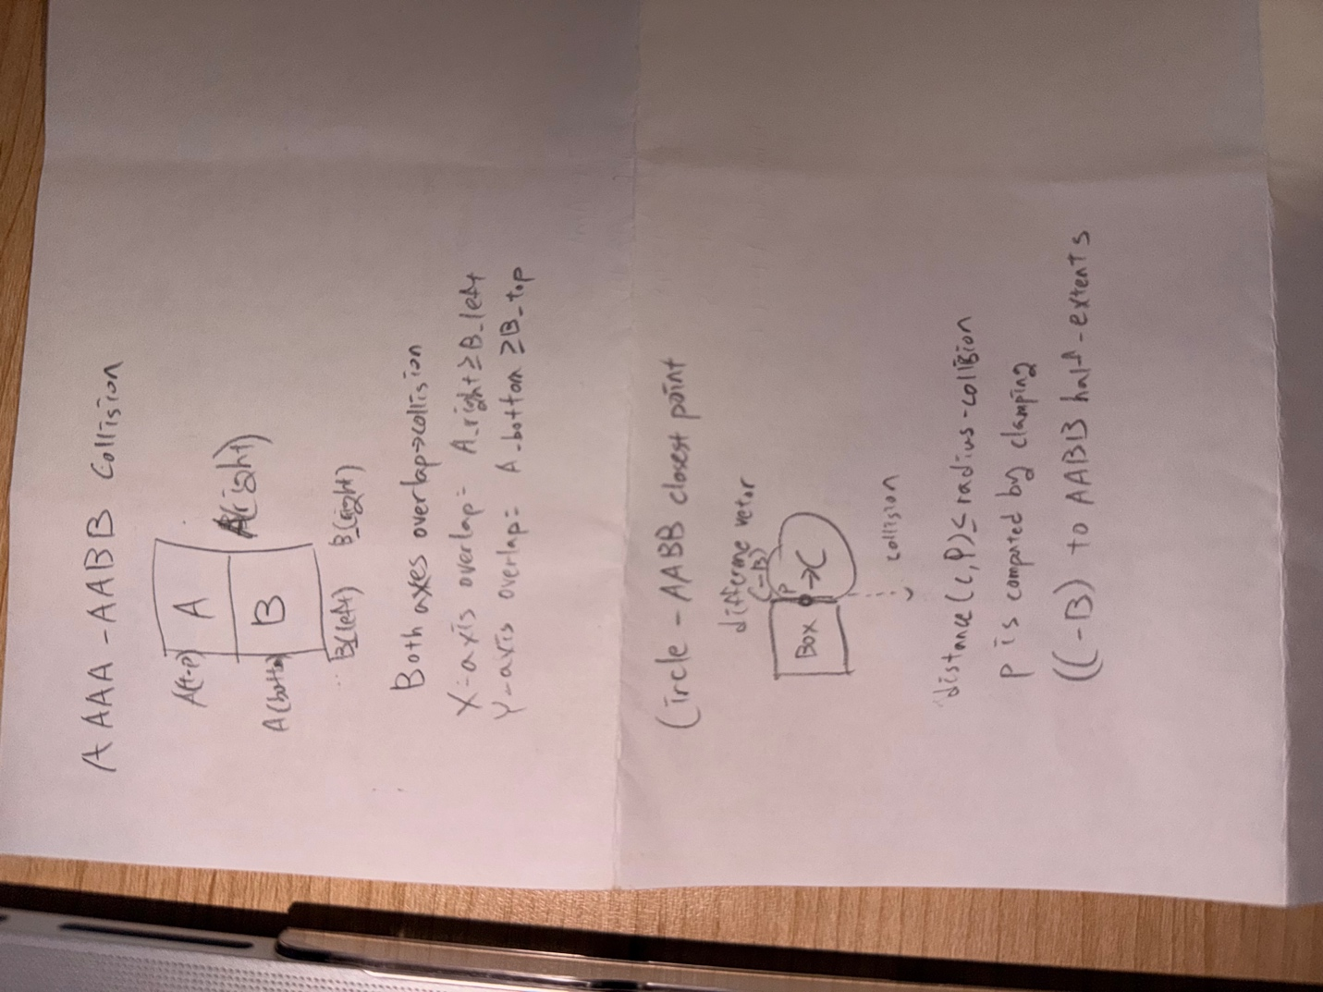
- Explain what the clamp function does and why it is important in the AABB–Circle detection algorithm.
The clamp function keeps a value inside a minimum and maximum range. In AABB–Circle collision detection, clamp is used to make sure the closest point I calculate stays inside the rectangle. This helps us correctly measure the distance from the circle to the box and decide if they are colliding.

Testing and Analysis
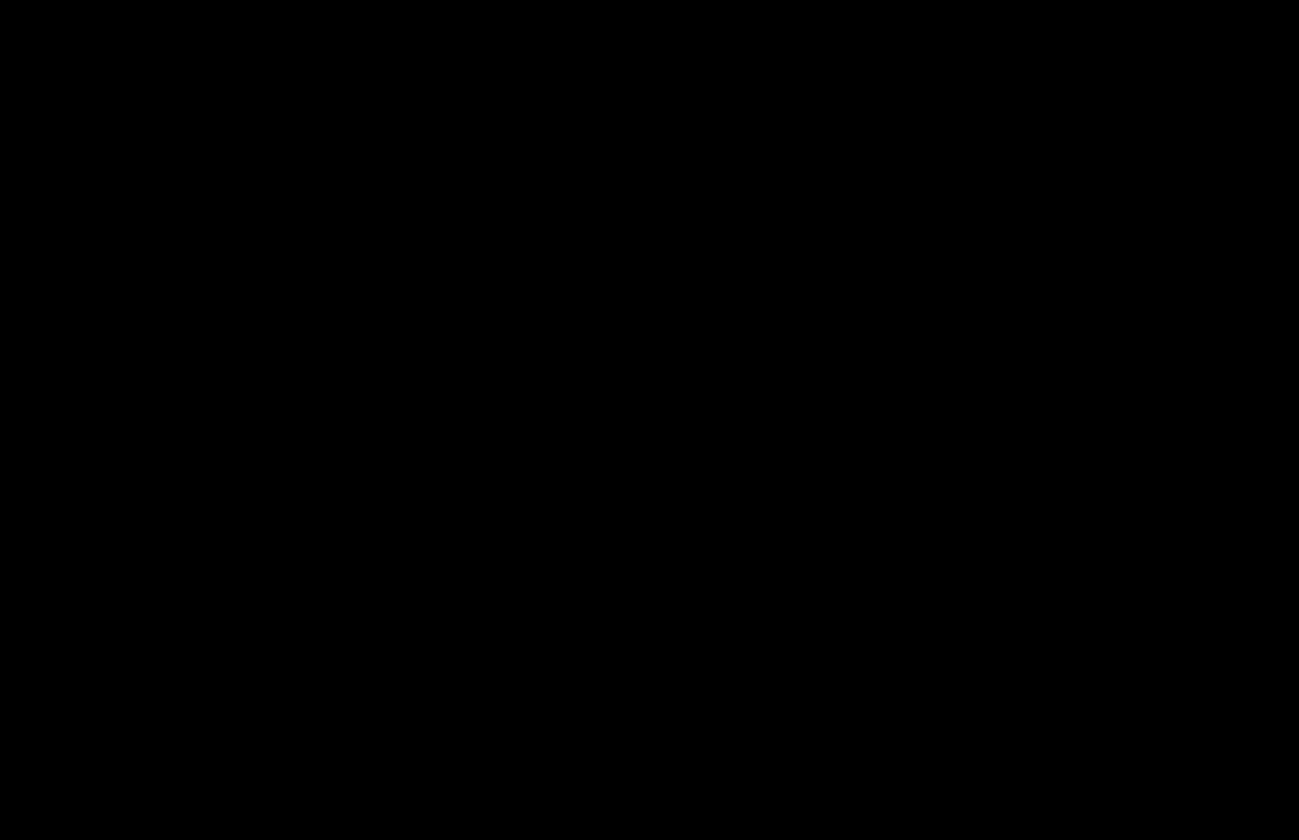
- Experiment with different ball sizes and brick dimensions. Record what happens to collision accuracy and realism.
EXPLANATION BELOW VIDEO
When I experimented with brick dimensions, wider bricks made collision detection smoother because the ball had more surface area to hit.
However, very thin bricks sometimes allowed the ball to pass through when moving quickly, which is a common tunneling effect in simple collision systems.
EXPLANATION ABOVE VIDEO
When I tested smaller ball sizes (radius = 10), the collision detection became less reliable.
Sometimes the ball visually touched the brick, but the collision was detected slightly late.
For very large ball sizes (radius = 100), the collision happened earlier than expected because the circular shape extended beyond the visible sprite.
This shows that the precision of AABB–circle detection depends heavily on the ball radius.
- Note any false collision detections and describe why they occur. Suggest how using more precise collision shapes could improve the behavior.
Note any false collision detections and describe why they occur
During testing, I noticed several false collision detections.
For example, when the ball approached the corner of a brick, it sometimes registered as a hit slightly earlier than expected.
This happens because circle–AABB collision uses a simplified distance check rather than pixel-perfect detection.
I also observed tunneling effects when the ball speed was high: the ball occasionally passed through thin bricks without triggering collision.
This occurs because the collision is only checked once per frame.
Suggest
The accuracy could be improved by using more precise collision shapes such as polygon colliders or pixel-mask collision.
Another solution is continuous collision detection (CCD), which checks the entire movement path of the ball instead of only checking at frame intervals.
This would prevent tunneling and make the game feel more realistic.

